Cash is King
by Tim Berry
April 27, 2004
This article looks at how to plan for cash in a business plan, understanding the critical elements that affect cash flow. You don’t want to be one of those businesses that goes broke even while producing profits.
Basic Cash Planning Example
Let’s start with a simple example. Illustration 1 looks at the business from the point of view of money coming in and money flowing out. Sales and profits are out of the picture, (although sales influences money in and costs and expenses influence money out).
In this very simple model, your sources of money are cash sales, payments from receivables, new loan money, and new investment. Your expenditures include buying widgets in cash, paying interest, paying bills as they come due (i.e. paying accounts payable), and paying off loans.
Illustration 1: Basic Cash Plan
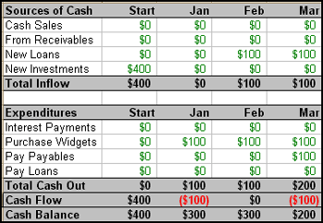
Even at this basic level, you can see the potential complications and the need for linking the numbers up with a computer. Your estimated receipts from accounts receivable must have a logical relationship to sales and the balance of accounts receivable. Likewise, your payments of accounts payable have to relate to the balances of payables and the costs and expenses that created the payables. Vital as this is to business survival, it is not nearly as intuitive as the sales forecast, personnel plan, or income statement. The mathematics and the financials are more complex.
A More Realistic Example
The cash plan can get complicated quickly when you deal with a more realistic business example. In the following illustrations, we’re going to look at the cash planning for a start-up company.
Beginning Assumptions
With Illustrations 2 and 3 we set the starting points, which are the projected income...
Illustration 2: Income Statement
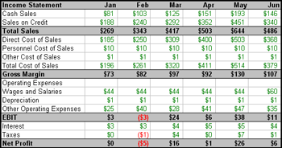
...and the starting balance.
Illustration 3: Starting Balance
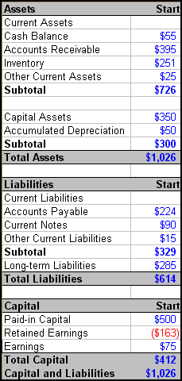
We see a simple example of business income, which we’ll use as a first step for planning cash. Sales hit a peak in May. The example already divides sales between cash sales and sales on credit. We also have a simplified version of wages and operating expenses so that we can focus on the cash plan instead of the income statement.

