You can protect yourself against viruses with a few simple steps:
- If you are truly worried about traditional (as opposed to e-mail) viruses, you should be running a more secure operating system like UNIX. You never hear about viruses on these operating systems because the security features keep viruses (and unwanted human visitors) away from your hard disk.
- If you are using an unsecured operating system, then buying virus protection software is a nice safeguard.
- If you simply avoid programs from unknown sources (like the Internet), and instead stick with commercial software purchased on CDs, you eliminate almost all of the risk from traditional viruses. In addition, you should disable floppy disk booting -- most computers now allow you to do this, and that will eliminate the risk of a boot sector virus coming in from a floppy disk accidentally left in the drive.
- You should make sure that Macro Virus Protection is enabled in all Microsoft applications, and you should NEVER run macros in a document unless you know what they do. There is seldom a good reason to add macros to a document, so avoiding all macros is a great policy.
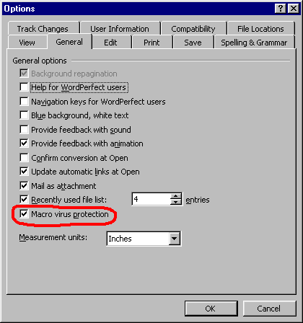
Open the Options dialog from the Tools menu in Microsoft Word and make sure that Macro Virus Protection is enabled, as shown.
- You should never double-click on an attachment that contains an executable that arrives as an e-mail attachment. Attachments that come in as Word files (.DOC), spreadsheets (.XLS), images (.GIF and .JPG), etc., are data files and they can do no damage (noting the macro virus problem in Word and Excel documents mentioned above). A file with an extension like EXE, COM or VBS is an executable, and an executable can do any sort of damage it wants. Once you run it, you have given it permission to do anything on your machine. The only defense is to never run executables that arrive via e-mail.
By following those simple steps, you can remain virus free.

