PC Assembly

Overview:

This section provides a step-by-step guide to assembling a PC, and includes descriptions and photographs of the parts that are involved. It is derived from web resources cited in the text; a particularly clear and informative resource has been Craig Reid’s Hardware Installation Guide available at http://www.wiu.edu/users/mscmr1/. Some of its structure has been adopted here.

Graphics and photographs are used with their creators’ permission.

The guide is intended as a sample workshop document to guide trainee staff through the assembly of PCs.

PC Assembly Guide

Before starting, verify that you have all of the necessary components at your workstation. Refer to the Components List for a description of parts listed below.

Checklist
1 IDE Hard Drive
1 Memory Module(s)
1 PCI Network Interface Card
1 Video Card (optional)
1 IDE CD ROM
1 IDE Floppy Drive
1 Processor
1 Heat Sync and Fan
2 IDE Cables
1 Floppy Drive Cable
1 Power Supply

Tools You Will Need
(www.how-computers-work.com/disassemble-the-computer.html)

Slot Screwdriver Set
1 Chip Puller
1 Needle-Nose Pliers
1 Tweezers
1 Hex-Head Allen-Wrench Set

Phillips screwdriver - you will use this the most as all screws are this type.
Torx screwdriver - most common size is T-10.
Long nose pliers - for picking up those tiny screws you drop.
A cup - to hold the small screws.
Pen and paper - for diagramming the component connections before you disassemble the computer.
Anti-static bag(s) - to prevent ESD damage to expansion cards.
Before you start:

Clean your work area of dust, debris, and anything else that might get in the way.

You must also take precautions against static electricity. A static discharge can damage or ruin your computer. Before opening your computer case and touching or removing any parts inside, you should ground yourself with a grounding strap.

A grounding strap prevents static electricity from building up in your body and discharging into the equipment. Static electricity can sometimes acquire a charge of 10,000 volts. Eighty volts are enough to hurt a computer.

General handling notes:

(1) Touch things as little as possible.
(2) Hold the parts by their edges.
(3) Avoid touching the motherboard components, chips, connectors, and leads.
(4) Avoid touching memory module contacts and chips
(5) Place the parts on a grounded antistatic surface or on the antistatic bag in which it came.

Basic Precautions:

Computer assembly requires some basic precautions:

“Never force computer parts into place - If you have to force a part into place, it is possible that you are inserting the wrong component or installing it improperly. Stop and check to see what you are doing wrong before you continue to build your computer.

Never open the power supply - The power supply has extremely high voltages inside which can be extremely dangerous.

Never work on your computer with the power on - Doing so can cause electrical surges that can damage your computer parts.”

http://www.build-your-own-cheap-computer.com/build-your-own-cheap-computer.html

Assembling a computer

This tutorial assumes that the motherboard has already been fitted into the case. If both the case and the motherboard are new, and haven’t been fitted, consult the product documentation for guidelines on attaching the motherboard to the case. There are too many variations in case shape and mounting method too document the procedure effectively.

About.com describes the process at the following location: http://peripherals.about.com/library/weekly/aa082402b.htm.

However, nothing will be as accurate or as informative as the original manufacturer’s documentation, which can be a significant factor in deciding what to buy. Pcmech.com’s useful Build Your Own PC tutorial advises:

“Make sure to look at the manual for your board and make sure you can understand it. Most well known brands have decent manuals. Asus, Abit, FIC, Tyan, Shuttle and a few others come with nice manuals. Another thing to keep in mind is that the better known manufacturers often have nice web sites, and you can get support info there, too. If you don’t know who the manufacturer is, of their website is utterly useless, think twice about using the board”

– http://www.pcmech.com/byopc/step/

Links to many motherboard manuals are listed here:

http://users.iafrica.com/g/gl/glynhall/hohweb/man2.htm

A note on sequence:

Some may find it easier to fit the CPU and fan before fastening the motherboard into position; different shapes of motherboard and case may mean it’s easier to fit the motherboard first. Once again, documentation should advise you.

Open The Case
Different cases open in different ways.
For some cases you need to:
  - Remove 4 or 5 screws in the back of the case. Be sure these screws hold the case and not some other component like the power supply.
  - Slide the case forward on its slots and remove it.
For other cases
  - Remove one thumbscrew or one or two Phillips head screws from the back of your case that may hold one or more panels.
  - Remove the top panel and/or one or more necessary side panels.
Orienting Yourself

Whether the computer is tall and thin or wide and fat, all computers resemble each other on the inside. Typically, there is one large printed circuit board inside, with other boards and wires attached to it. (Not all computers have the devices listed on the picture below (many, for instance, don’t have a tape drive). But they all have a motherboard).

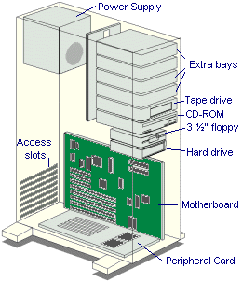
(http://www.jegsworks.com/Lessons/lesson10/lesson10-4.htm)

This large board is called the motherboard or the mainboard.

Here’s a close-up of the motherboard, with all its parts listed.
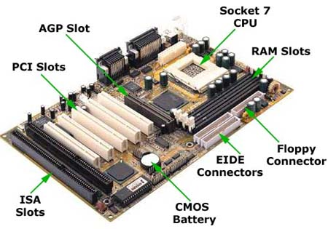
(http://www.techtutorials.com/tutorials/images/motherboard.jpg)

Here’s a more schematic view:

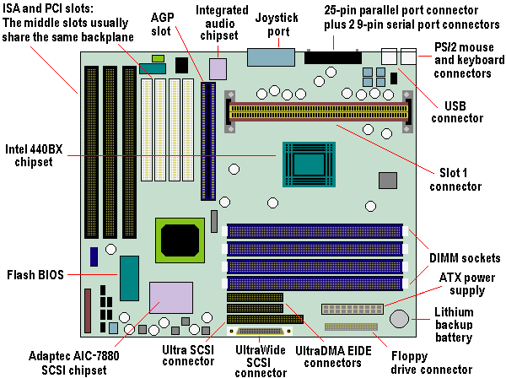
(http://www.pctechguide.com/01mboards.htm)

Installing Components:

As you can see by the shapes and connections on the motherboard, there are generally two kinds of ways to attach devices to the motherboard: via the slots, or via cables. Generally speaking, slot devices only need to be slid into the slots, but devices attached by cable need to be connected to the power supply as well as to the motherboard.

Installing Slot Devices:

(1) Installing the Central Processing Unit (CPU)

The CPU can be thought of as the "brains" of the computer. This is the component that receives requests from the user and translates these requests into data that the required components can understand.

Not all CPUs are shaped the same way, so not all boards can be fitted with all CPUs. The difference is in what’s called the CPU socket.

The typical socket is flat and square. To show you how to align the CPU with the socket where it needs to be installed, triangular, or bevelled, edges mark the location of Pin 1. Its shape matches angled corners on the socket. This helps to ensure that the CPU is oriented correctly.

But some older motherboard models, such as those built for Intel’s Pentium II machines, use a Single-Edge Connection socket, where the processor slides into a rectangular retainer. Two black sleeves rise up from the motherboard to hold the CPU and fan in place. Clips help to keep it secure.

Example 1 : Typical socket
Tom’s Hardware Guide: Jan 15, 2001. Do It Yourself PC System
http://www4.tomshardware.com/howto/20010115/pcsystem-05.html#processor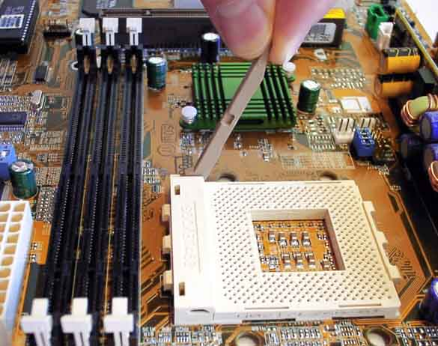

Example 2: The Single Edge Connector Socket (common to Pentium II and III)
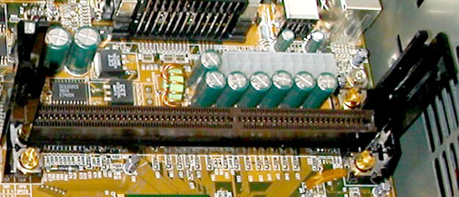

http://www.wiu.edu/users/mscmr1/step1.htm

Installing the CPU

Locate the processor slot on the main board. Note that the processor only connects to the chamber one way.

For Square sockets: Because the CPU is so sensitive, its slot is very intricate. It’s flat and generally square. Examine the top of the processor that should have a small dot in one of the corners. This dot indicates where pin one is located on the bottom of the processor. Now look at the socket on the motherboard: this socket should have a missing hole or should have a 1 indicating pin one. Position the processor so both pin1 and hole1 match and then place the processor down.

Some newer processors also have another safety measure designed to protect the pins on the processor during insertion. It’s called a zif-socket, or a zero-insertion-force socket. The main addition is the presence of a lock to hold the CPU in place.

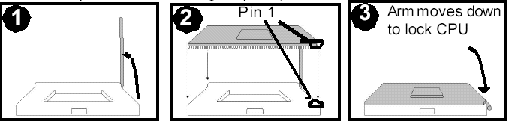
Source: Tyan Computer Corporation - http://www.tyan.com
(ftp://ftp.tyan.com/manuals/m_s2266_201.pdf)

Insertion is easy. Lift the lever lock. Then, as above, carefully install the CPU by aligning Pin 1 on the CPU with Pin 1 on the socket, making sure the pins actually fit into the socket. Do not force the CPU into the socket: check the pin alignment of the CPU pins to socket holes before pressing down. Lower the lever arm until the CPU is held in place.

For single edge connectors (SECs): Do not force the processor into the slot; make sure it’s oriented correctly. Find the exposed end of the processor and lower it onto the circuit, using the support arms as a guide. Press down firmly until the processor is securely seated into the chamber. Pull the retaining clips at the top of the chamber away from the processor to lock it down.

A Note on CPUs & Motherboards:

Not all CPUs match all motherboards. Most motherboards will accept more than one type of CPU as far as model, manufacturer, and speed is concerned, but they generally only accept one socket type. The motherboard's manual – even old ones are generally still available in web archives or on manufacturers’ websites - will tell you what different types of CPUs it will accommodate. The major CPU manufacturers include Intel, Motorola, IBM and Advanced Micro Devices (AMD). For a thorough discussion of motherboard shapes (or form factors), design changes and evolution, visit: http://www.pctechguide.com/01mboards.htm

Heat Sink and Fan

If the CPU is brand new, you will have to attach a heat sink or cooler to it. A heat sink looks like a three-dimensional comb – rows and columns of metal teeth, each designed to lead heat away from the chip. A fan screws on top of the heat sink.

The heat sink will generally snap right into a notched brace that straddles the CPU socket. It’s a good idea to use what’s called thermal compound to make sure that there’s a snug fit between the chip and the heatsink. Thermal compound can be purchased from any computer parts dealer.

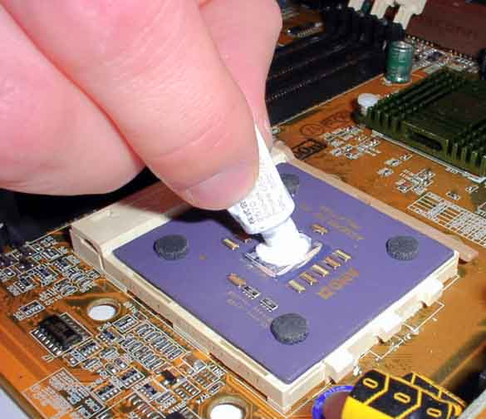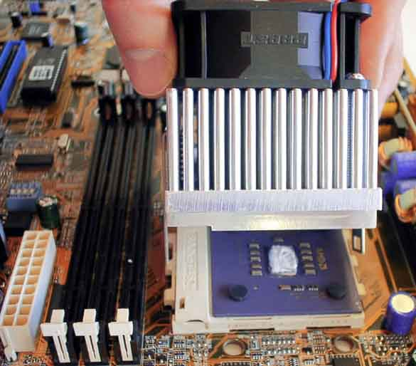
Tom’s Hardware Guide: Jan 15, 2001. Do It Yourself PC System
(http://www4.tomshardware.com/howto/20010115/pcsystem-06.html)

When attaching the heat sink clip to a socket processor be careful not to scratch the motherboard with the clip. Be gentle when attaching the heat sink bracket: if too much pressure is applied the plastic clip it will break.

Installing The Memory (RAM)

1) Locate the memory banks on the main board. Most main boards will have two or three black banks for memory slots.

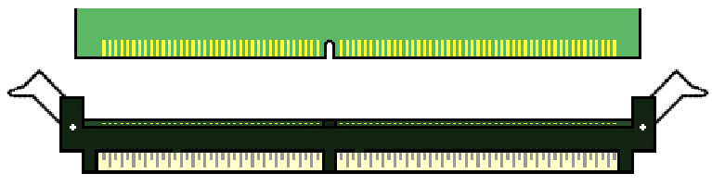
Source: Tyan Computer Corporation - http://www.tyan.com
(ftp://ftp.tyan.com/manuals/m_s2266_201.pdf)

Make sure that the retention clips are open, or pressed outward from the banks. Slide the memory into the bank, making sure that the slot on the module orients to the slot on the bank. There is only one way the memory can fit properly. Make sure that the short row of pins is lined up with the short gap in the socket, just as the long row of pins should line up with the long gap in the socket.

4) Using two hands, press down (press and hold – don’t rock the module) on both sides of the memory until the retention clips lock into position. The clips will fold to lock in the memory under your pressure.

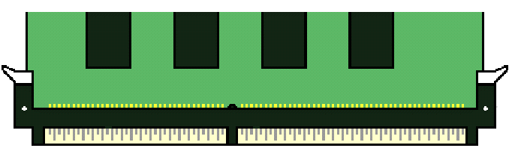
Source: Tyan Computer Corporation - http://www.tyan.com
(ftp://ftp.tyan.com/manuals/m_s2266_201.pdf)

You should not have to manually fold the retention clips. They are designed to fold into the lock position when the RAM is seated into its bank. If the retention clips do not fold, remove the chip and make sure that it is oriented correctly.

Installing PCI devices

The most common devices that slide into PCI (it stands for Peripheral Component Interconnect) slots are network cards (or Network Interface Cards (NIC)) and sound cards.

PCIs are usually indicated on a main board as a white slot. They are most commonly anchored on the motherboard near the rear of the case so that external cables can be connected to them.
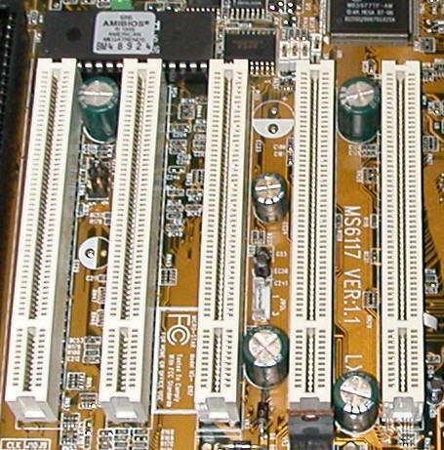
PCI slots. http://www.wiu.edu/users/mscmr1/step1.htm

Most cards will simply slide into place in the way that RAM does. A notch in the bottom of the card matches a break in the PCI slot to make sure the device slides in the right way around.

After the PCI card is in place, its metal backplate should be flush with the rear of the case. Fasten it to the case with a screw through the pre-drilled hole. (The screw is typically supplied by the card manufacturer).

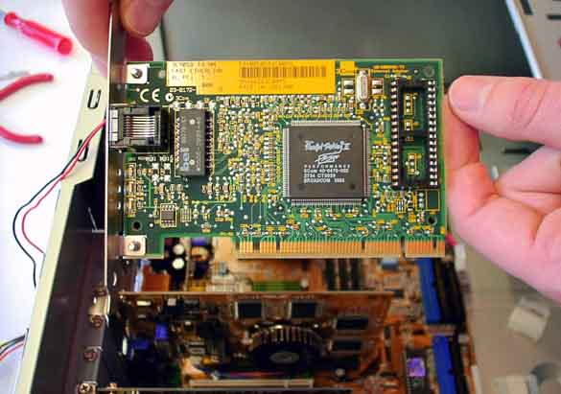
Tom’s Hardware Guide: Jan 15, 2001. Do It Yourself PC System
(http://www4.tomshardware.com/howto/20010115/pcsystem-10.html)

Installing the Video Card

It’s not always necessary to install a video card; some motherboards already have what’s called an on-board graphics chip. Video cards go in just the way PCI devices do, but sometimes they fit only into a specially designed slot called and AGP (Accelerated Graphics Port) slot.

To find out if your motherboard has an on board graphics card, look at the rear of the computer to see if there’s a vga port, often coloured blue.. If it doesn’t have one of these already, you’ll need to install a video card to attach a monitor.

Installing IDE Devices

Three kinds of devices attach to the computer’s motherboard via a piece of cable called an IDE cable. The IDE cable is grey, thin and wide, with one hard plastic gridded fitting on each end; sometimes there’s one more fitting in the middle. Each fitting has a squared notch on one side, called a guide. It makes sure you can’t put the IDE cable in upside down.

The three devices that attach with an IDE cable are the hard drive, the CDROM and the floppy or stiffy drive.

The hard drive and CDROM should go on separate cables. The stiffy drive is also a device attached via IDE, but it has its own special type of cable.

Step One: Install the Hard Drive

It takes three steps to install a hard drive. Set the jumpers, connect the drive to the mainboard with an IDE cable, and insert the power cables. The latter two tasks are sometimes easier to do after the drive has been fit into the bay.

First let’s take a look at what a hard drive looks like at the back.

Hard drives that attach via an IDE cable are typically ATA hard drives. An ATA hard drive will typically have the two kinds of connections shown below. The row of pins on the left carry data; the row of thicker pins on the right supply electrical power from the power supply to the drive itself.

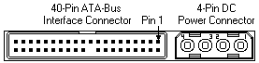

Another form of drive is a SCSI drive. All SCSI variations use one of three connectors: They look like this:
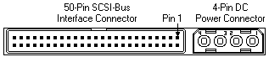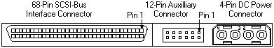
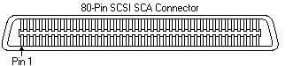
http://www.seagate.com/support/kb/disc/howto/interface_know.html

Set the Jumpers

A drive’s settings determine how it behaves with other drives. If two drives are on the same cable, you have to specify the priority of one drive in relation to the other. The terms used are master and slave.

These priorities are set using a small set of pins at the rear of the drive called jumpers. A movable plastic clip can be placed between a pair of jumper pins to trigger certain settings. Inside the plastic clip are pieces of metal that close a circuit when the jumper is in place. The state of the circuit (open or closed) determines the jumper setting.

The grid below refers to the jumper settings for Seagate’s ATA drives with capacities of more than 20GB. (Settings for other drives can be found at manufacturers’ websites).
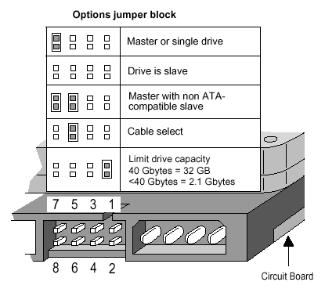
http://www.seagate.com/support/kb/disc/howto/ata_install_tshoot.html

If a drive appears alone on the IDE cable, it should be set to master. It should be fitted to the connector at the end of the IDE cable (the master position), not to the one in the middle. It is possible to install an IDE device, such as the CD ROM, to the master position on the IDE cable while the jumper settings are set to slave. This configuration will work as long as that device does not share the IDE cable with any other device.

Use needle-nosed pliers to set the jumper in the correct position. The correct way to set the jumper switches is usually written somewhere on the case of the disk. If it is not, look for engraved abbreviations such as MA or SL above or below sets of pins.

Attach the cable
When connecting IDE devices to the main board, it is important that you correctly orient the IDE drive and the main board. If the IDE cable is not installed properly to the main board, the computer will not recognize any drive on that cable. If it is not correctly installed to the device, the computer will not recognize that device. Also, incorrect orientation of either the drive or the cable can damage the drive itself.
In order to reduce the chance of error, the IDE cable, the main board and the drive all have markings that help you tell if something is attached the right way around and anchor your orientation. These anchors are called Pin One. (It’s similar to the convention of marking pin one on the CPU with a slanted edge).
Pin one, in almost all instances, can be recognized on the IDE cable with a red stripe along one side of the length of the cable. This includes floppy drives. The connectors are shaped so that they can only slide into the board one way. If the IDE connectors are not slotted, you will have to look closely to the main board for the "1" pin. Most IDE devices are also slotted to ensure pin one is correctly oriented. If not, a general rule to follow is that pin one (the red strip) will face the power connection on the IDE device. Likewise, on most IDE devices, the red power wire will face the pin one on the IDE cable (red-red). The picture of the rear of the hard drive above clearly shows pin one next to the power supply.
Put one IDE connector into the back of the drive; put the other onto the connector on the main board, making sure that Pin 1 is oriented correctly (pin 1 is identified with a red stripe on the ribbon cable and by the number 1 on the primary master connector on the main board).
Each IDE connector on the main board should be labelled clearly. The picture below shows three male IDE connectors; the type and rank (FDC means floppy drive controller; IDE2 refers to the secondary IDE channel; IDE1 refers to the primary channel) is clearly printed next to the connector. The position of pin one is printed in smaller font next to the connectors themselves.
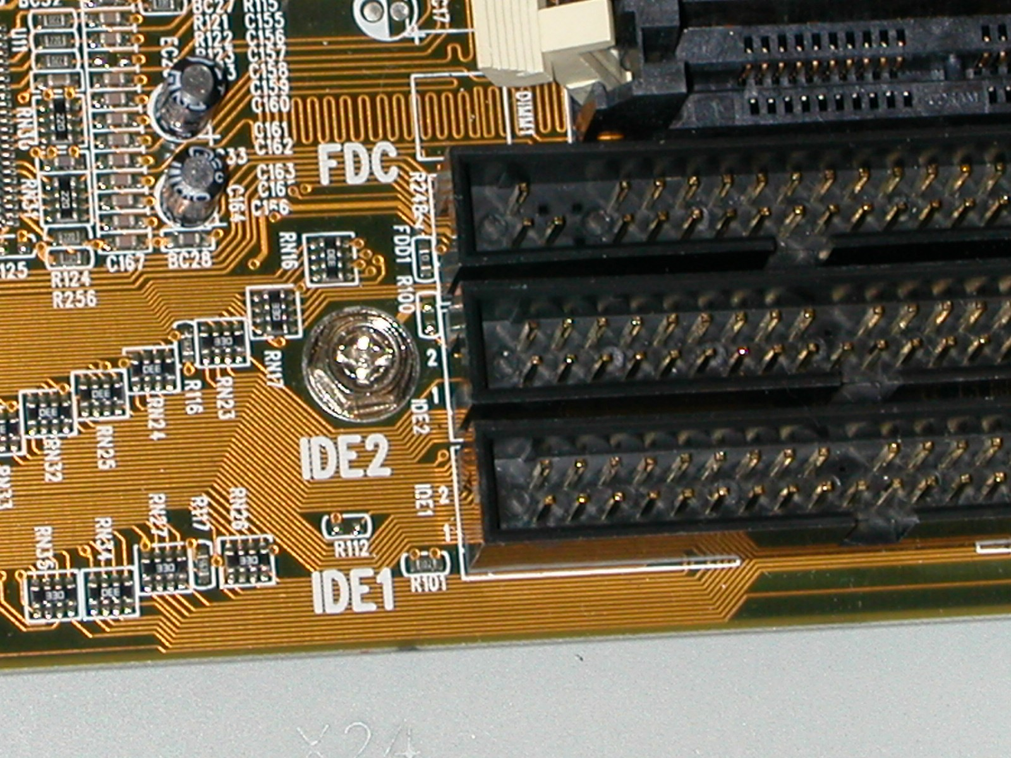
http://www.wiu.edu/users/mscmr1/step2.htm

Place the drive in the bay on the computer's chassis and secure the drive down using 4 drive screws.

Fitting the CD ROM

In most cases, you should install a CD-ROM drive as the secondary master. That means it’s on a separate IDE channel from the hard drive, but that it’s the highest priority on that channel. The steps resemble those applicable to hard drives: verify the jumpers, attach the cable connectors to the drive and to the board, and then fit the CDROM into its tray.

Verify that the drive is set to be a "Master" on a single IDE channel. The jumper settings are indicated on the drive itself.

Connect an IDE Ribbon cable to the main board making sure that Pin 1 is oriented correctly (pin 1 is identified with a red stripe on the ribbon cable and by the number 1 on the secondary master connector on the main board). Refer the graphic above for assistance.

Attach the CD-ROM drive to the IDE Ribbon Cable on its master position (at the end of the IDE Ribbon Cable). Make sure that the IDE Ribbon Cable is position to pin 1 on the CD-ROM drive (Pin 1 on the CD ROM drive faces the power connection).

Place the drive in the 5.25" bay at the top of the computer's chassis and secure the drive down using 4 drive screws.

Step Three: Install the Floppy Drive

The floppy or stiffy drive is also an IDE device, but its cable is narrower than the ones used to attach the CDROM and hard drive. The floppy drive controller cable is twisted at one end and split near the middle. The twist in the cable allows two floppy drives to be connected to the cable. The first one must be connected to the fitting placed after the twist in the cable (at the very end); the second must be attached to the middle connector. It’s very rare to install more than one stiffy drive in a computer any more.

Despite the difference in the width between the hard drive’s IDE cable and the floppy controller cable, the same conventions are used to attach the drive: the connectors are shaped or ‘keyed’ so that they can’t be put in upside down. The IDE ribbon cable should have a red stripe down one side to indicate where pin one is. Just as with the hard drive and CDROM, pin one on a floppy is typically closer to the power supply pins.

Align the IDE cable with pin one on the drive
Insert the connector into the drive
Align the IDE cable with pin one on the motherboard
Insert the cable into the fastener on the motherboard.

After attaching the IDE cable to the motherboard, fit the stiffy drive into place and secure it with screws.

Connecting the Power Supply:

The power supply is responsible for providing power to IDE devices and the main board itself. It converts DC (direct current) to AC (alternating current) and supplies the correct amount of voltage to the computer hardware.

There are two main kinds of wires attached to the power supply: a 20-pin mainboard power cable, and a set of up to five rectangular, four-pin connectors used to supply power to the different drives on the computer. They each consist of four wires: 1 red, 1 yellow and 2 black. The shape of the milky-white plastic connectors ensure that they fit drives only one way. Older power supplies have two-piece power connectors.

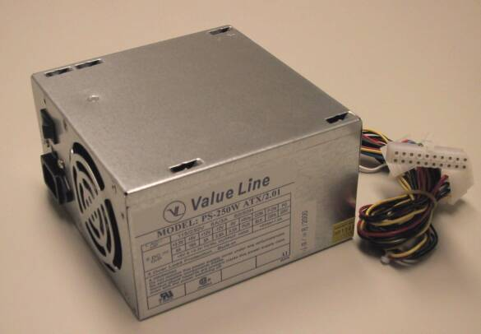
http://www.wiu.edu/users/mscmr1/step3.htm

Although most power supplies have common power connectors, some main boards will require different connections to it. Make sure that you have read the main board guide and any component hardware guides before attempting to install the power supply.

Step 1: Inspect the power supply: Make sure it tightly attached to the case, make sure it is free of dust, and make sure it set to the voltage area of your area- 110V for the US and 220V for outside countries.

Step 2: Connect the power to the main board

Locate the main board's 20-pin power connection. Note that the power supply will only connect to this connector one way. Slide the power supply lead into the plastic fitting.

Step 3: Connect IDE devices

Once again, the floppy drive power supply is thinner than the ones for the CDROM and hard drive. The power slot on the IDE drive consists of just four thick pins; it’s easy to identify it because it’s so much bigger than the IDE connector and jumper pins next to it.

Attach each IDE device to the power supply via the four-pin white connector.

Step 4: Feed power lines from the case to the mainboard.

The final step in connecting the power is fitting the case’s switch, lights and speaker (a 6 or 8-cm speaker designed to sound warnings and issue beeps – it’s not for playing music) to the panel on the mainboard. The location of these connectors differs from board to board, but, generally speaking they’re clearly labelled – if you can read the small type and decipher the abbreviations. Often they all appear clustered together along one edge of the motherboard. The wiring for each device is thin, coloured, and sometimes twisted together in pairs or threes; plastic female connectors consist of two- or three-pin housings.

Here is a short list of the parts you’ll at least have to connect. There may be more.

Power switch - Power / PWR-SW
Reset switch - Reset
Power LED - Power LED / PWR-LED
Hard drive LED - HDD-LED / IDE LED
Speaker - SPK / Speaker

Post Assembly Visual Check

Work space within the system case is often very limited and it is very easy to accidentally loosen a connection. Before closing the case check the following one more time:

The 110/220V switch is set to 220V
The IDE cables are straight and secure.
The power cables are in place.
The CPU fan is free of stray wires that could obstruct its rotation.
Slot devices are properly fitted and fastened into place with a screw
Ports are well aligned with their holes in the case backing
The memory is firmly seated in place
No stray pieces of metal, wire or plastic are at risk of short circuiting the motherboard
The motherboard is well clear of contact with the case

Process Test & Preparation for installing an operating system
(adapted from FreeGeek’s FreekBox building how to
http://www.freegeek.org/howto/building/allinone.html)

Plug the monitor and computer in and turn the machine on. Make sure there is no disk in the floppy drive. There should be no disk in the CD Rom tray either. Since the hard drive has been formatted, the computer should boot only into the bios, and then stop the boot process when it can’t find an operating system. It’s safe to reboot or turn off the computer when it complains it can’t find an operating systen.

So boot the computer a few times to check that everything’s detected and working, then shut down the machine. Then check to see if the CPU or hard drive are especially hot.

Check for the following

Does the power light come on?
Can you hear the CPU fan and see it spin?
Put your hand over the power supply fan grille. Is it pushing out air?
Did the lights on the keyboard flash once a few seconds after the computer came on?

Now watch the POST (Power On Self Test) process. The POST is a series of checks that the BIOS program (more on BIOS later) runs to make sure that all the hardware is in working order. While the BIOS is performing the POST process it will usually display information about some of the hardware it finds. At the least, it will almost always display the speed of the processor and how much RAM it finds. Take note of these values. Is the processor detected? Is all of the RAM you inserted being detected? Generally, the BIOS will cause a single beep to be sounded if the POST is successful or will sound multiple or continuous beeps if the POST fails.
Common problems include:

Nothing happens. The screen is blank and the computer looks dead:
Check the power supply and its connection to the mainboard.
Check the cord from the power supply to actual power outlet. Do other devices work on that outlet?
You hear multiple or continuous beeps:
Did you forget to put RAM into the machine?
Is video card seated correctly in slot?
Try swapping memory or video card.
You see some kind of image or corporate logo, but no useful information:
POST is probably happening. Read the screen for instructions, or try pressing ESC or TAB.

Machine seems to turn on but the screen is blank:
Is the video card seated correctly in slot?
Try swapping the memory or video card.
Possibly the processor is bad?
Keyboard failure:
Check that the keyboard is plugged in to the appropriate port. (It's easy on PS/2 systems to get it plugged into the mouse port accidentally).
Try swapping the keyboard

The floppy drive light should turn on during boot, but it shouldn’t be on all the time. If it is, it means the IDE cable is backward, and the pin one on the cable is misaligned. Turn the computer off and reconnect it.

If the system passes all of these qualitative tests, reboot it.

Watch POST again, and then try to enter the bios as it reboots.

Enter BIOS Setup

Is the BIOS functioning, or is it password protected?

The BIOS (Basic Input Output System) is a small program that exists in a special chip on the mainboard. You may not have thought about it before, but how does the computer know what to do when you first power it on? This is one of the primary functions of the BIOS: to get the computer up and running when you turn on the power. The BIOS also controls various aspects of the mainboards hardware, such as the RAM, integrated peripherals (e.g. serial ports, parallel port, USB, video), and startup options. Most every computer you may encounter will have a BIOS configuration area which is usally accessible by pressing a special key just after the computer is powered on.

Each BIOS is different. There are several companies which develop BIOS programs and each has a unique way of doing things. The interfaces are different, and the various options may have different names. Despite these differences, it is important to remember that regardless of the interface, the basic functionality of all BIOSs is roughly equivalent. Although the number of settings can at first seem daunting, it is good consolation to know that, for our purposes, the default settings are generally desirable.

Getting into the BIOS setup area:

Pay close attention to the monitor after you first power on the machine. Various information will be printed to the screen and there will almost always be an indication as to how to enter the BIOS setup area. Look for text similar to "Setup", "Enter setup", "BIOS settings", or the like. Next to this text should be an indication as to which key you need to press to get into the BIOS setup area. Depending on the type and version of BIOS this key will change, but will almost always be one of the following: Del, F1, F2, F10, or Esc. You will generally have a limited amount of time to press this key before the BIOS takes this option away, so keep your eyes on the screen and act quickly.

Restore BIOS Defaults

1. Reset the Bios to default settings

Detailed Instructions

We don't know who, or under what circumstances, the previous owner operated this machine. Therefore, we will do ourselves a huge favor and avoid headaches by reverting the BIOS to default or factory settings before we do anything else. When you first enter the BIOS setup area look around the screen for an option that refers to "BIOS defaults" or "Setup defaults". Exercise this option.

Auto Detect Hard Drive

In BIOS there should be an option that looks somewhat like

"IDE HDD AUTO DETECTION"

Select this option to configure your hard drive. It should give you multiple choices, but go with the default.

This will only detect your hardrive, so don't worry if it comes up blank for the IDE channel that your CD-Rom is attached to.

Set Boot Order

1. Set the floppy drive as the first boot device

Browse around the BIOS and look for an option that indicates boot order or sequence. We want the machine to always attempt to boot from a floppy disk prior to attempting a boot from the hard disk. Generally, this is the default setting, but we should double check that this is the case. Many times the BIOS will refer to boot order in terms of "A" and "C". "A" refers to your floppy disk and "C" refers to your hard disk. If your BIOS refers to boot order in these terms, make sure that the order is something like "A,C...". It doesn't matter what comes after "C", just that the order starts with "A,C..."

Save and exit the bios. The computer will reboot. When it finishes POST, turn the computer off.

Check the CPU heat sink and the hard drive. Each should feel a little warm, but not hot.

Replace the case and move the computer to the configuration area.

"This document is based on draft text taken from the bridges.org report
"Set-up and Operation of a Computer Production and Support Centre - A
How-To Guide", to be published July 2004."

