Configuration

Whenever you’re installing or reinstalling an operating system, it’s often necessary to download drivers for the particular components that are on the computer you’re rebuilding.

Drivers are small programs that work together with an operating system to make particular parts of an operating system work. Technically, you need a driver for any piece of hardware that a BIOS (see Components and Concepts for a description) doesn’t understand.

But many operating systems now detect a lot of common hardware, and the drivers for those devices are pre-included in the installation media. This isn’t the case for all pieces of software – especially when you’re using an old operating system like Windows 98 and have devices like video cards, sound cards, and network cards. Here’s a basic rule: the newer the operating system and the more popular the piece of equipment, the greater the chance that the operating system will recognize and have drivers for the piece of equipment.

So if the operating system doesn’t recognize the devices, these drivers have to be downloaded from the Internet. (When people buy a new computer, they often receive their drivers on a CD ROM in the same package as their computers.) It’s very rare that a refurbisher or reseller includes driver disks with a shipment of computers.

Because it’s hard to predict what hardware will be detected and what won’t be, drivers should be installed only after you’ve installed an operating system and found the hardware not to be supported.

How to tell if you need to download drivers:

After installing a Windows operating system, right click on ‘My Computer’. Select properties. From the System Properties window, select Device Manager (if windows 98) or Hardware Profiles > Device Manager if Windows 2000.

Undetected Devices will be listed differently from devices Windows recognizes. They appear with yellow question marks.

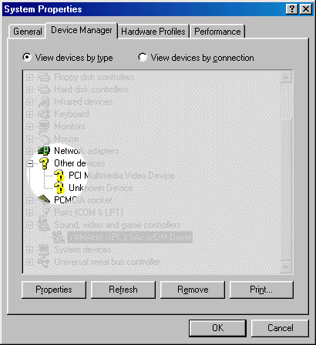

BIOS

Another consideration is the BIOS. Manufacturers frequently issue BIOS updates to improve the way the computers handle low-level operations. A BIOS update must be installed a little differently than a driver, but the concepts – identifying the device, searching the web for the drivers, downloading the software – are the same.

An operating system won’t tell you directly if the BIOS needs updating. The only way to be sure is to visit the manufacturers’ site to see if there is an update available.

Getting Drivers: Tier One Computers

Tier 1 manufacturers such as IBM, Dell, HP, its subsidiary Compaq, and a few others make it very easy to find and download drivers and install BIOS updates because each of their computers was made in accordance with a model number. By law, anything made with the same model number must have the same equipment inside. So if you know the model number, you know what’s inside.

But that’s not the whole story: like all regulations, the devil is in the detail. For instance, the IBM’s PC 300GL must be among the most common computers ever built – but despite sounding and looking like the same model, not all computers that have 300GL stickers on the outside are the same on the inside. Technically, the 300 GL isn’t a model designation at all. IBM calls its 300GL a computer family – and there are more than 20 types within that family. Each type has multiple models.

So it can be complicated, but most manufacturers’ sites’ support pages begin with a tutorial or guideline for finding out your model number. At the appropriate PC manufacturers’ technical support website address (consult the list below), submit the make and model number (and, in some cases, indicate the operating system you’re going to install) to see a list of components that need drivers. If the IBM unit you want to build is the one you’re browsing with, you can even click on a link to have IBM identify the machine. The instructions are generally clear. Be sure to read carefully.

Once you’ve correctly identified the machine you’re looking to update, the website will present a list of drivers and utilities to download. The list can be long, but read carefully – many options will apply to some versions of operating system, or involve features that you don’t have or need (such as backup or data transfer utilities). If there are multiple versions of the same driver or BIOS, take the one released most recently.

Download each driver. (Some manufacturers let you package a number of drivers into a single download that can be unzipped once they’ve been saved on your local computer). Always save drivers for the same computer to the same folder. Name the folders after the computer model so that the updates will be easy to find in the future.

Getting Drivers: When Computers aren’t Tier 1

Other kinds of computers will be a bit more difficult to find drivers for. Generally speaking the place to start is with the motherboard. Identify it to find out what other drivers are needed.

Identifying the Motherboard.

When a computer boots, the first screen to show is often tells you much of what you need to know. Typically, a logo appears in the upper part of the screen, and a number is flashed in the lower part. This is the BIOS identification string.

What is a BIOS ID string?

“The BIOS String ID number is assigned to every motherboard made. It is not always unique but there is usually some good info hidden in the string. The most useful is the portion which identifies the manufacturer of the motherboard. In some rare cases BIOS ID strings are not valid and will not be useful in identifying a motherboard. Some of these cases involve pirated boards, OEM products, or a bad flash routine.”
--http://www.motherboards.org/articlesd/tech-planations/13_1.html

How to identify the motherboard:

1. Turn the system power off.
2. Unplug your keyboard or hold down one of the keys on the keyboard
3. Power-on the system (you should get a keyboard error)
4. Notice the long string of numbers in the lower left hand corner of your screen. This is your BIOS identification string. It will look like one of these:

Bios Identification Screen

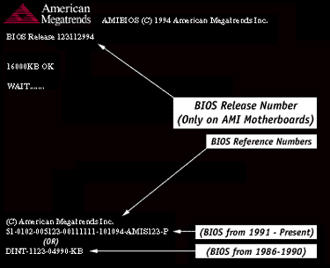
http://www.ami.com/support/bios.cfm

It identifies the manufacturer and a release number. Here is another screenshot from Award, another manufacturer.

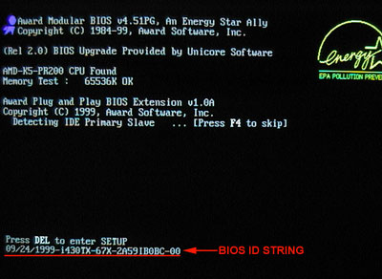
www.biosupgrade.co.uk/ awardid.jpg

The BIOS ID string is clearly shown on the lower left. The manufacturer is on the upper left.

From the BIOS ID string you can often get a listing of the kinds of on-board components (on-board components are part of the mainboard itself) that are installed along side the CPU, such as the video or vga chipset, and any on-board sound.

Write down the ID string when it appears on the screen. Before any boot sequence starts, reboot and double-check the string you’ve written down.

Searching for the Drivers

If you know the manufacturer, start with its support site. (Common manufacturers are listed below). You can also simply type the BIOS ID string into Google and see if it returns any results. Try it as it’s written on screen first, then gradually take out hypens and break up the string into chunks if you’re not getting any useful results.

A good resource is the set of motherboards ID tools at motherboards.org, as well as the listing of manufactuers sites motherboards.org.cz.

Once you’ve identified the motherboard – its maker, type, and version – you should be able to track down the drivers for the on-board features. Drivers can be downloaded from the motherboard or chipset sites in the same way that they are presented on PC manufacturers’ sites: identify the model number, choose from a number of options, download the drivers.

Download each driver. Download each driver. (Some manufacturers let you package a number of drivers into a single download that can be unzipped once they’ve been saved on your local computer). Always save drivers for the same computer to the same folder. Name the folders after the computer model so that the updates will be easy to find in the future.

Installing Drivers and BIOS updates

BIOS

BIOS updates need to be installed from what’s called a flash utility. It overwrites the memory where the BIOS is stored, a process known as ‘flashing’. Sometimes the utility is bundled with the BIOS update, sometimes the utility and the update are two programs you have to copy to separate floppies. Often instructions are available from the same place as the download. Sometimes the updates will come with a file called README.TXT. Be sure to read it: it will explain the procedure.

A tutorial and guidance on BIOS flashing is available here:

http://www.pctechguide.com/tutorials/BIOS1.htm

A great resource on everything about BIOS is

http://www.wimsbios.com/index.htm?/HTML1/faq.html

Another resource is

http://www.computerhope.com/help/bios.htm

Drivers

Most drivers for Windows come in a form that is executable. Installation typically just requires a double-click to launch the program. Expect to have to reboot.

Most drivers for Linux (more aptly called modules), if they’ve been sourced from the manufacturer, are available in a package form (such as .deb and .rpm) that package management applications can take care of. Some hardware management utilities – Mandrake’s HardDrake, SuSE’s YaST, for example -- may also streamline the process.

Some rare and older versions of hardware modules may only come as source code, and require configuration to install. Be sure to get as much documentation you can find before struggling to install modules from source. Search user groups and mailing lists – chances are someone else has encountered the same problem as you have.

Start with by searching with as many specific terms as you can. For a problem with an Nvidia graphics card on a SuSE 8.2 system, search

Nvidia SuSE 8.2 module

Search the distribution’s support site. Often you can search mailing lists hosted by the distribution as well.

www.linuxquestions.org is a good site for general information

www.linuxnewbie.org
http://www.tuxfiles.org/
http://www.justlinux.com/

Also search newsgroups related to GNU/Linux. (Search usenet groups with a web interface such as Google Groups or Gmane.)

comp.os.linux.answers (moderated) : FAQs, HOWTOs A good place to start!
comp.os.linux.hardware Hardware-related discussions
comp.os.linux.setup Setup and configuration of Linux systems
comp.os.linux.networking Networking related topics.
comp.os.linux.x Using the X Window System comp.os.linux.misc Miscellaneous topics.

IBM Support and Downloads

http://www-307.ibm.com/pc/support/site.wss/home.do

HP Support and Downloads

http://welcome.hp.com/country/us/en/support.html

HP and Compaq

http://h10025.www1.hp.com/ewfrf/wc/siteHome?lc=en&cc=us&dlc=en

Dell Product Support

http://support.euro.dell.com/za/en/filelib/index.asp

Sounds and Video Cards

ESS

http://www.esstech.com/techsupp/faq-identify.shtm

Ati

http://www.ati.com/support/driver.html

CreativeLabs

http://us.creative.com/support/identifyproduct/

Motherboards

American Megatrends

Via

http://www.viaarena.com/?PageID=2

Sis

http://www.sis.com/support/

MSI - Microstar

http://www.msi.com.tw/program/support/driver/dvr/spt_dvr_list.php

Gigabyte

http://www.gigabyte.com.tw/Tree/Tree_63.htm

ASUS

http://www.asus.com.tw/support/support.aspx

http://www.wimsbios.com/index.htm?/HTML1/bios.html

